# Propellor calculation description

## Flowchart

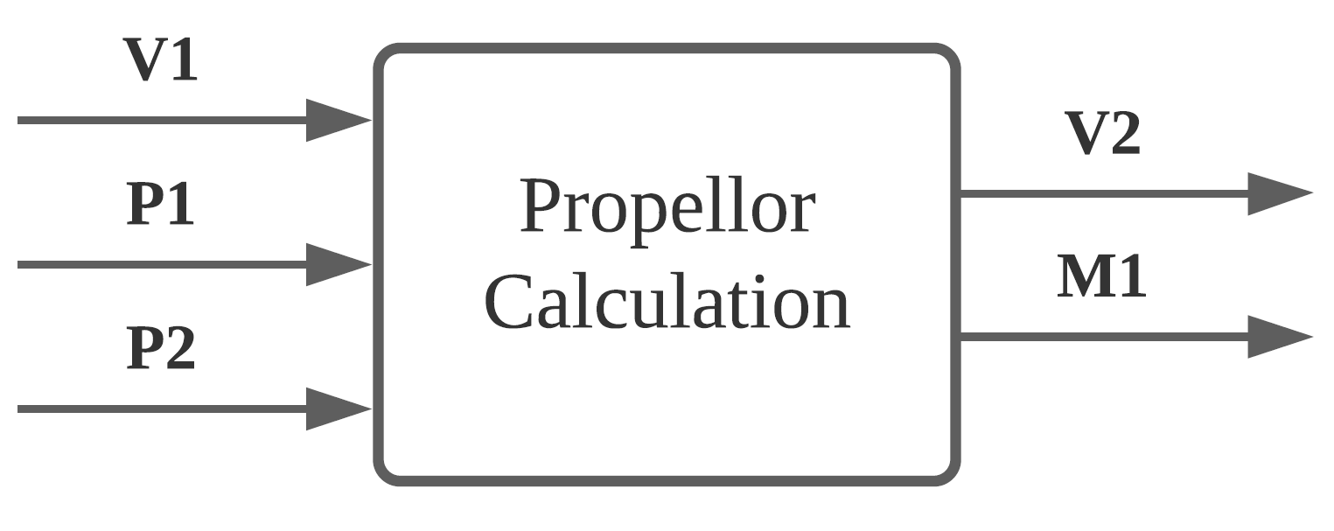

Figure 1 Propellor component flowchart

## Unique identifiers

|  |  |
| --- | --- |
| Unique ID | Long Name |
| V1 | Input from user-interface sub-system |
| V2 | Output to user-interface sub-system |
| B1 | Feedback to bearing component |

## Table of limits

|  |  |  |  |  |
| --- | --- | --- | --- | --- |
| Interaction | Symbol | Min. | Max. | Unit |
| -> V1 | | | | |
| *Input from user-interface sub-system* | | | | |
| Boat speed | Vb | 0 | 8,5 | m/s |
| Propeller diameter | $$d_{prop}$$ | 0,1 | 0,5 | m |
| Liquid density | $$ρ$$ | 980 | 1000 | kg/m3 |
| Thrust deduction coefficient | t | 0 | 1 | - |
| Wake fraction coefficient | w | 0 | 1 | - |
| Propeller properties table: Changing according to Vb | Fr | 0 | 500 | N |
| η | 0 | 100 | % |
| $$K_{T}$$ | 0 | 1 | - |
| $$K_{Q}$$ | 0 | 1 | - |
| <- V2 | | | | |
| *Output to user-interface sub-system* | | | | |
| Thrust | $$F_{T}$$ | 0 | 500 | N |
| Rotational speed propeller | $$ω_{P}$$ | 0 | 2200 | rpm |
| Power output | $$P_{output}$$ | 0 | 8400 | W |
| Power loss | $$P_{loss}$$ | 0 | 8400 | W |
| <- B1 | | | | |
| *Feedback to bearing component* | | | | |
| Rotational speed required | $$n_{req}$$ | 0 | 2200 | rpm |
| Torque required | $$T_{req}$$ | 0 | 3500 | Nm |